

**UNIVERSITY OF PETROLEUM & ENERGY STUDIES**

**Dehradun**

**CONTINOUS INTEGRATION**

**AND**

**CONTINOUS DELIVERY**

**Name: Aakarshit Agarwal**

**Course: B. TECH CSE DevOps (2018-22)**

**Roll no.: R171218001**

**Sapid: 500067782**

**Experiment-11**

**VAGRANT**

1. **Download vagrant**

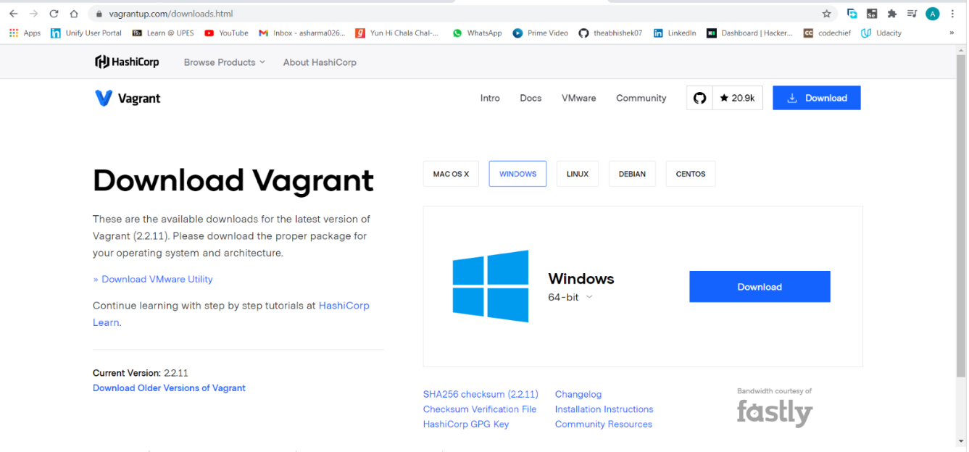

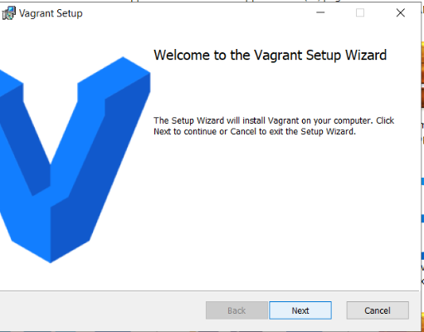

1. **check vagrant version**

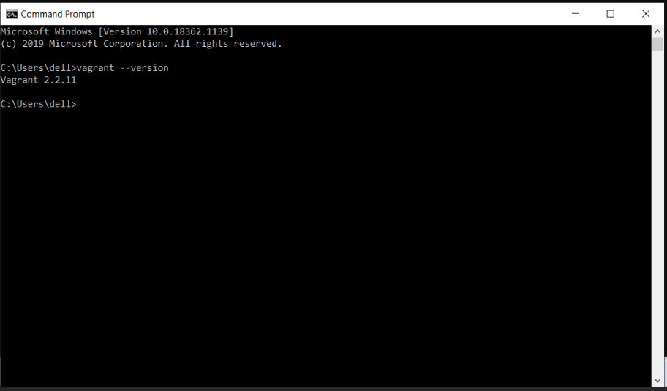

1. **create a folder and then go to that folder and do vagrant init**

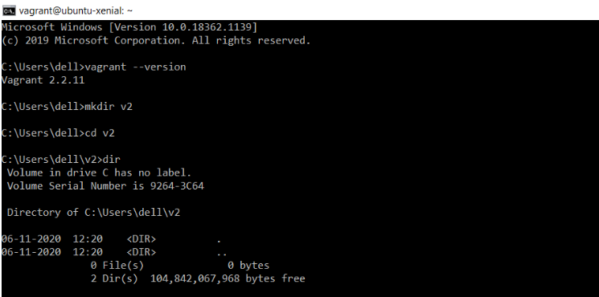

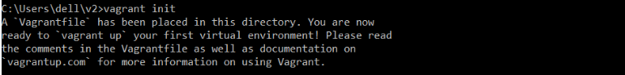

1. **open vagrantfile and do the changes in “config.vm.box = "ubuntu/trusty64"**

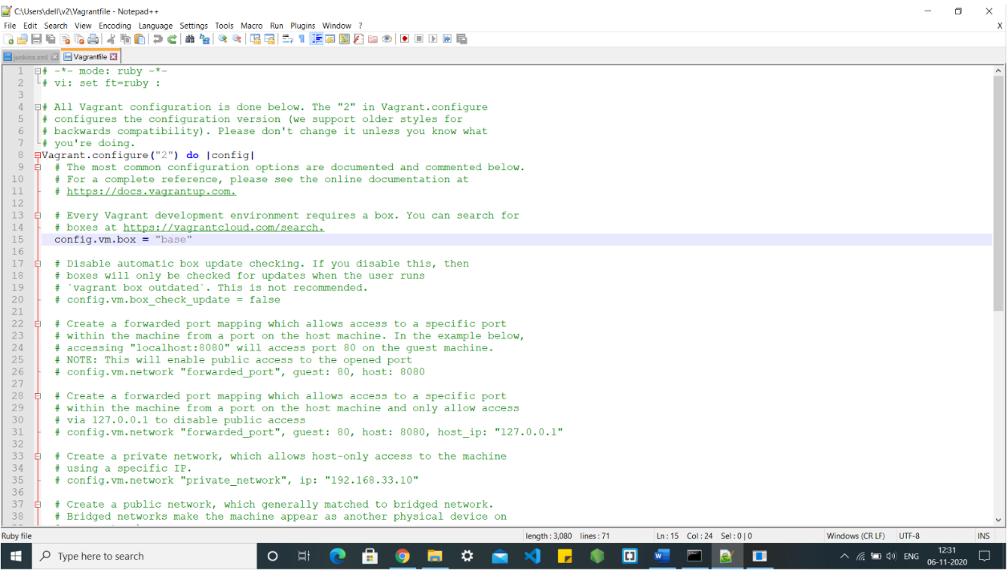

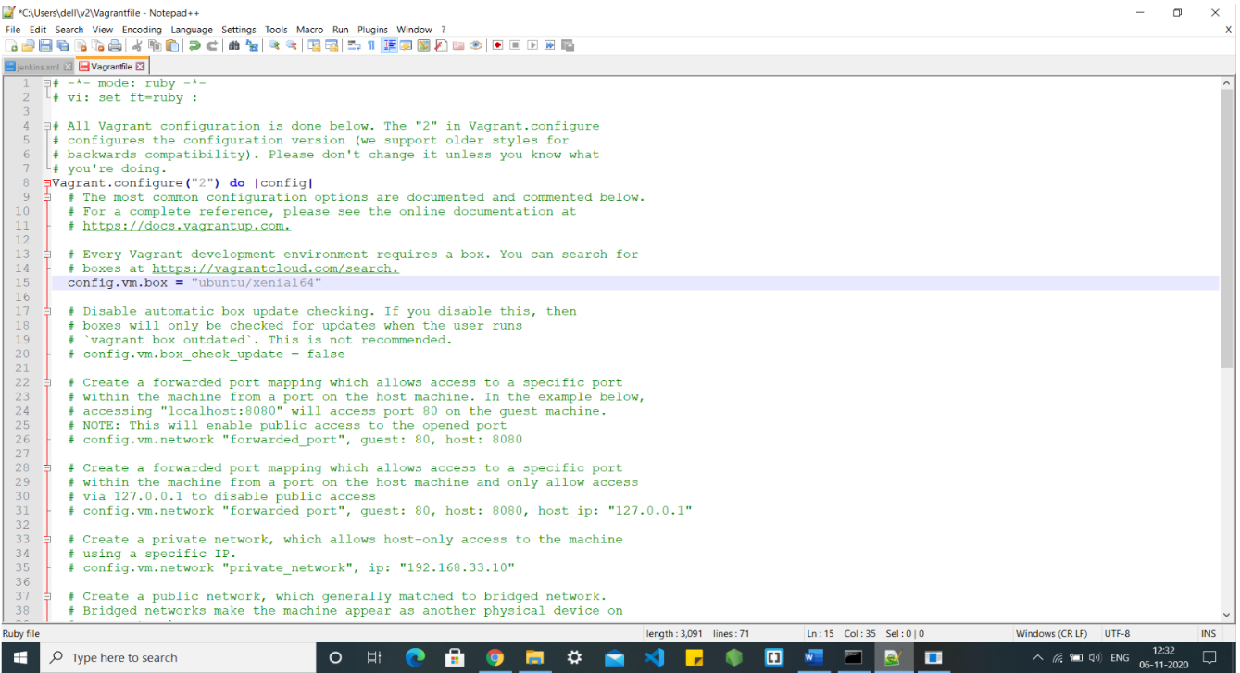

1. **run vagrant up command**

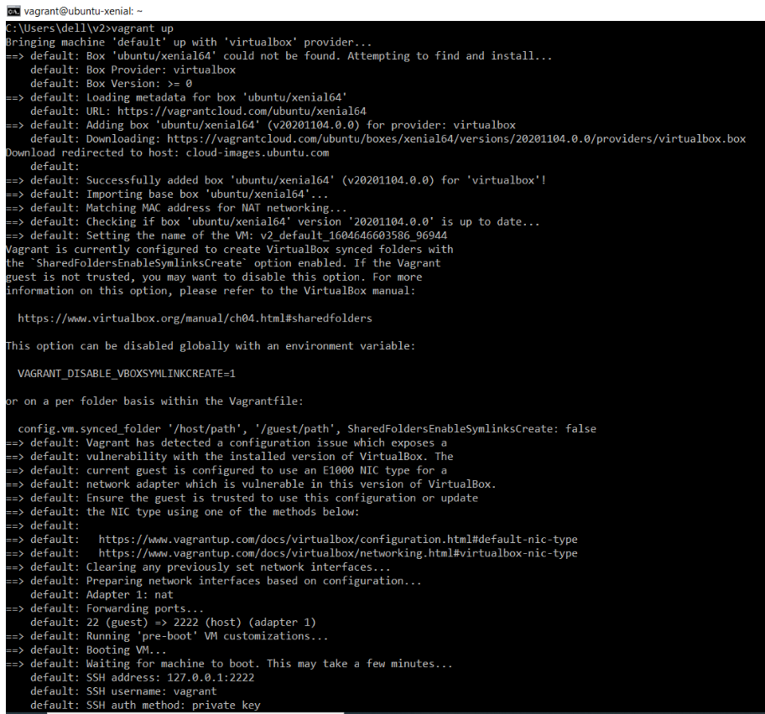

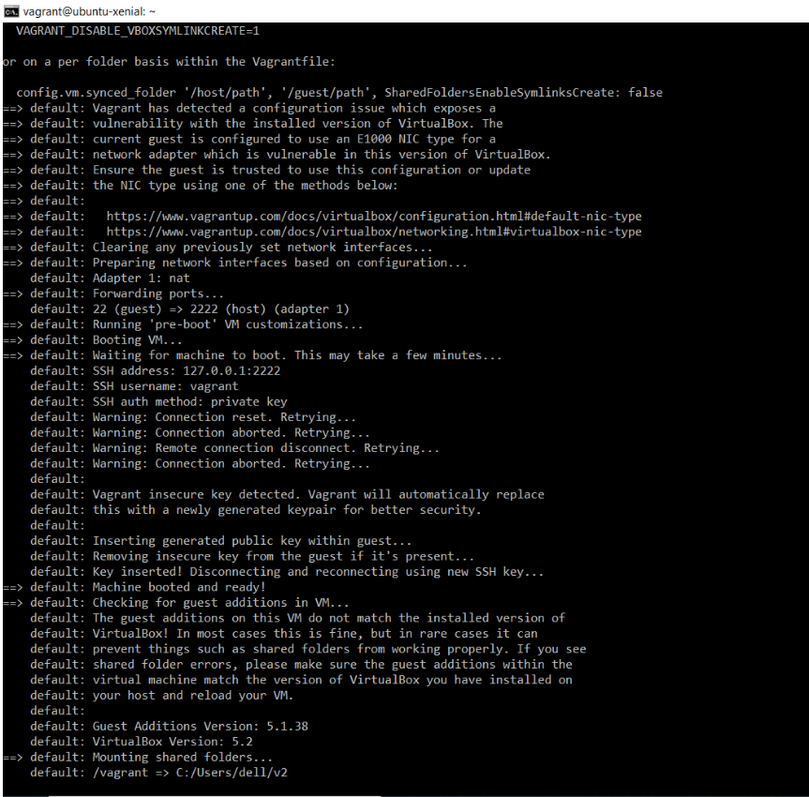

1. **run vagrant SSH**

